Sindiswa Jachin Shongwe
Practical 1: BrightLight Data Analytics Coding Practical Basic SQL Syntax

Question 1
-------------------------------------------------------------------------------------------------------
-- Q1. Display all columns for all transactions.
-- Expected output: All columns
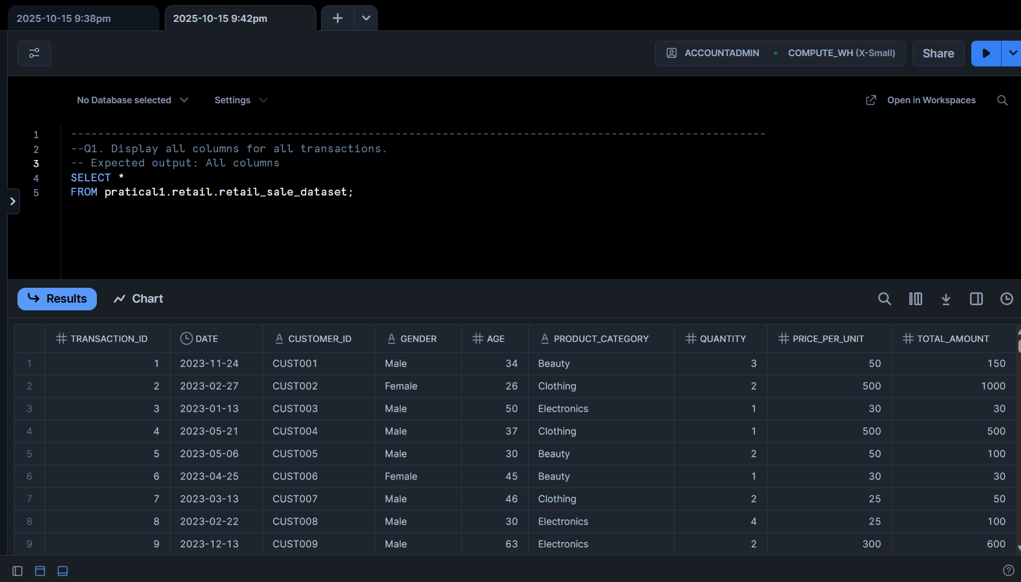

Question 2
-------------------------------------------------------------------------------------------------------
-- Q2. Display only the Transaction ID, Date, and Customer ID for all records.
-- Expected output: Transaction ID, Date, Customer ID

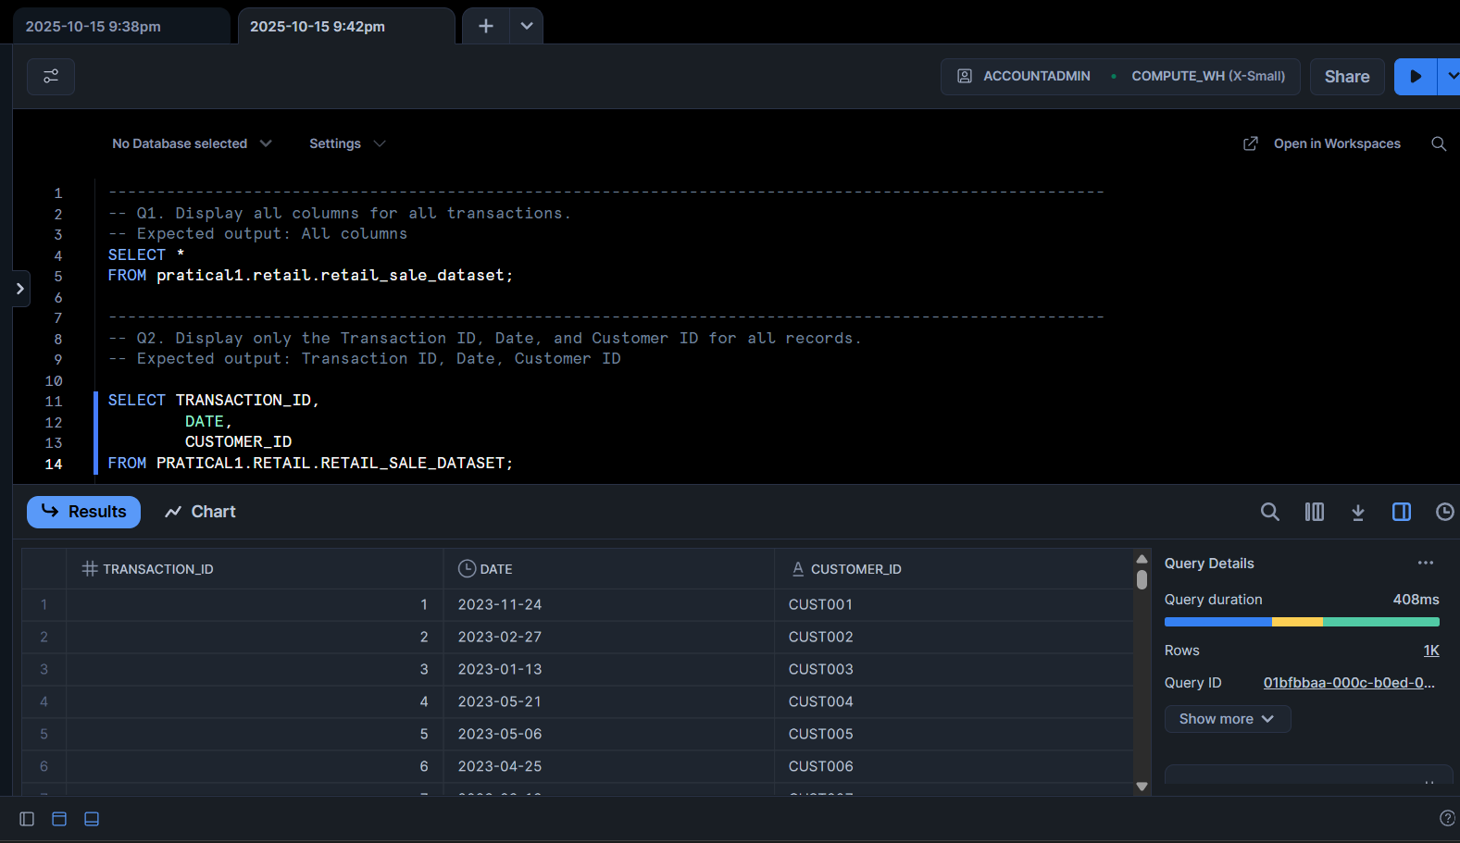

Question 3

-------------------------------------------------------------------------------------------------------
-- Q3. Display all the distinct product categories in the dataset.
-- Expected output: Product Category

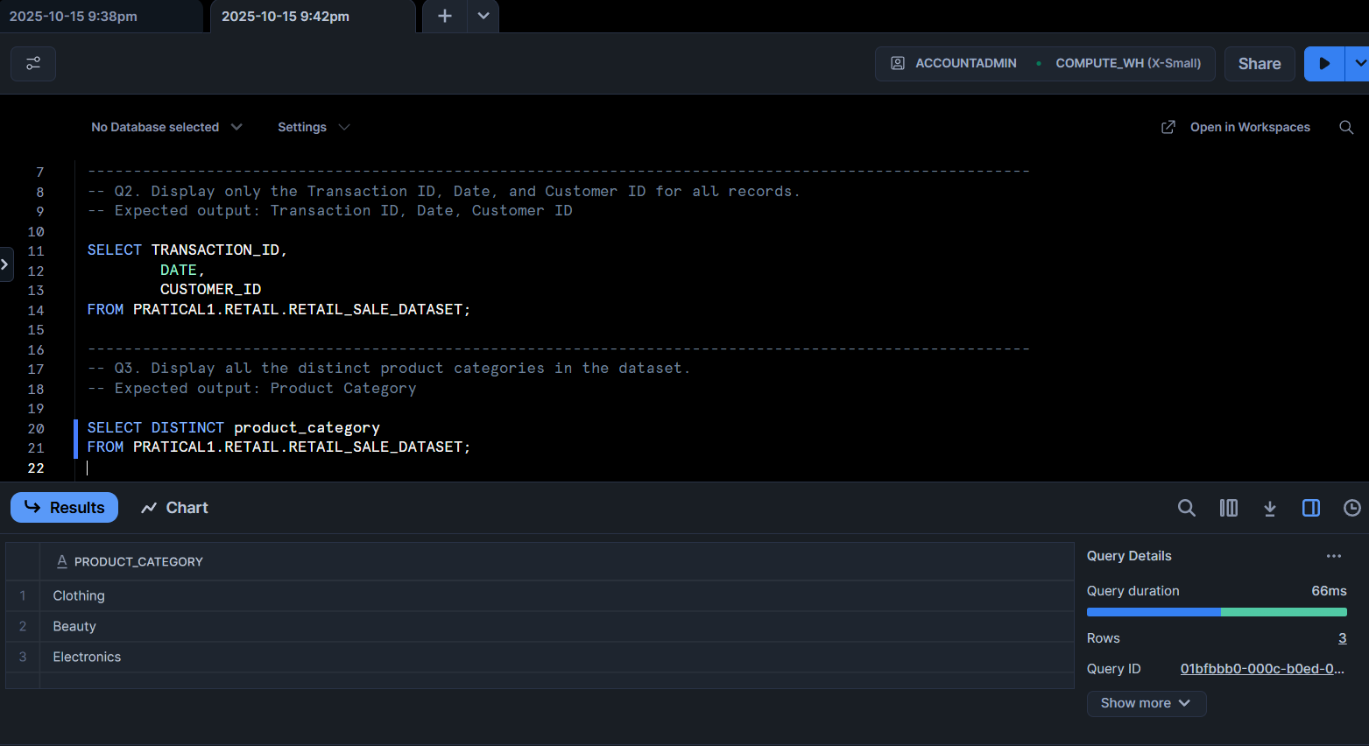

-------------------------------------------------------------------------------------------------------
-- Q4. Display all the distinct gender values in the dataset.
-- Expected output: Gender
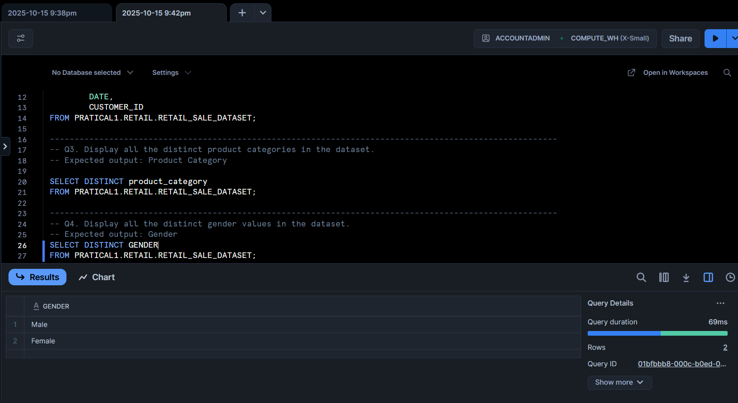
-------------------------------------------------------------------------------------------------------
-- Q5. Display all transactions where the Age is greater than 40.
-- Expected output: All columns
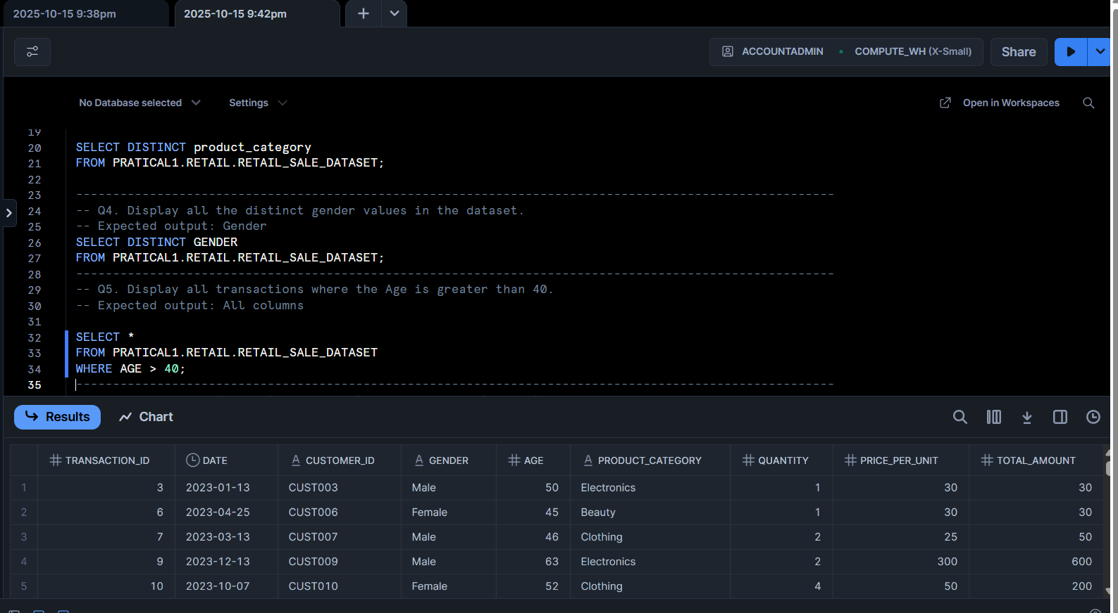

-------------------------------------------------------------------------------------------------------
-- Q6. Display all transactions where the Price per Unit is between 100 and 500.
-- Expected output: All columns

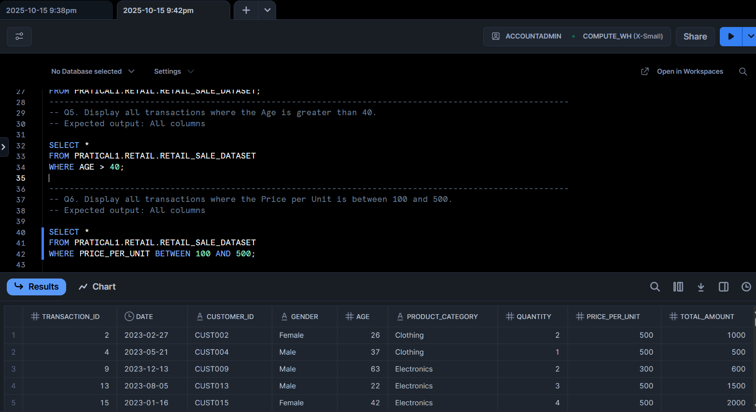

-------------------------------------------------------------------------------------------------------
-- Q7. Display all transactions where the Product Category is either 'Beauty' or 'Electronics'.
--Expected output: All columns
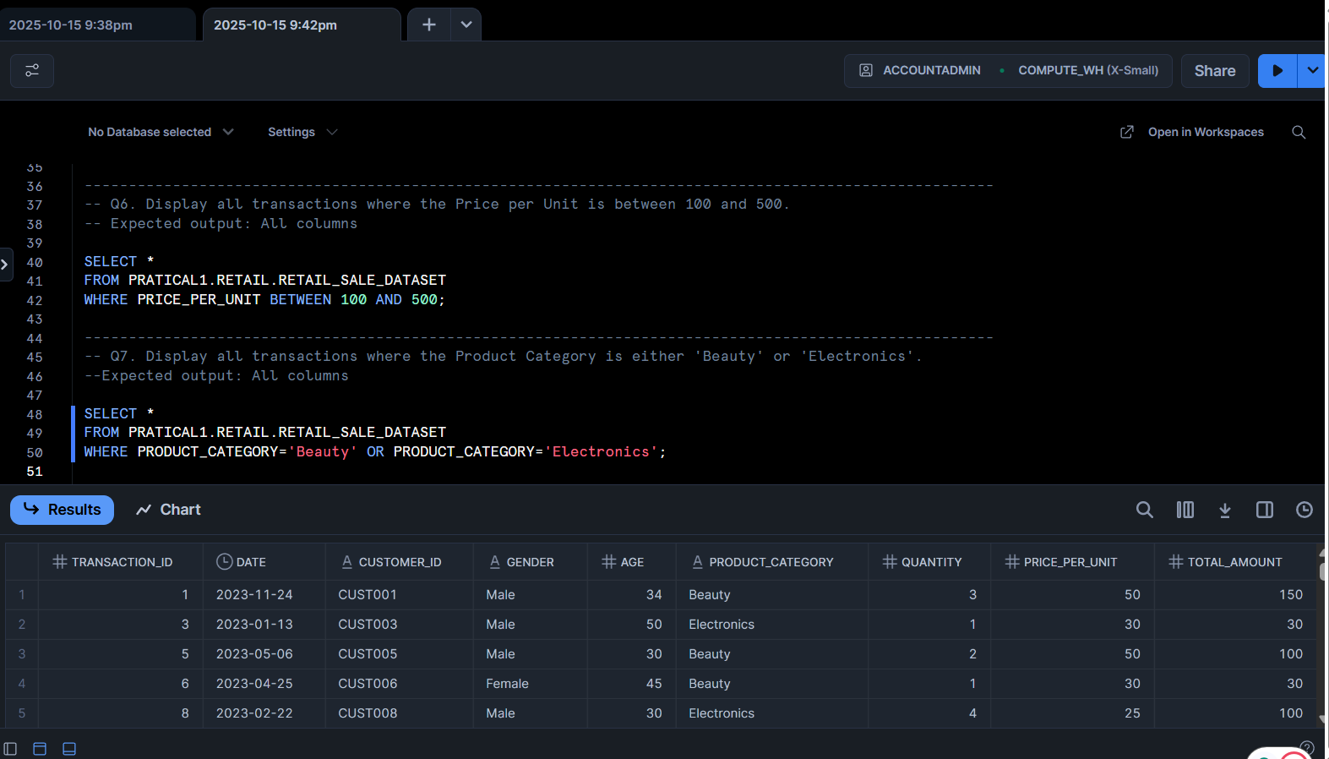

-------------------------------------------------------------------------------------------------------
-- Q8. Display all transactions where the Product Category is not 'Clothing'.
-- Expected output: All columns

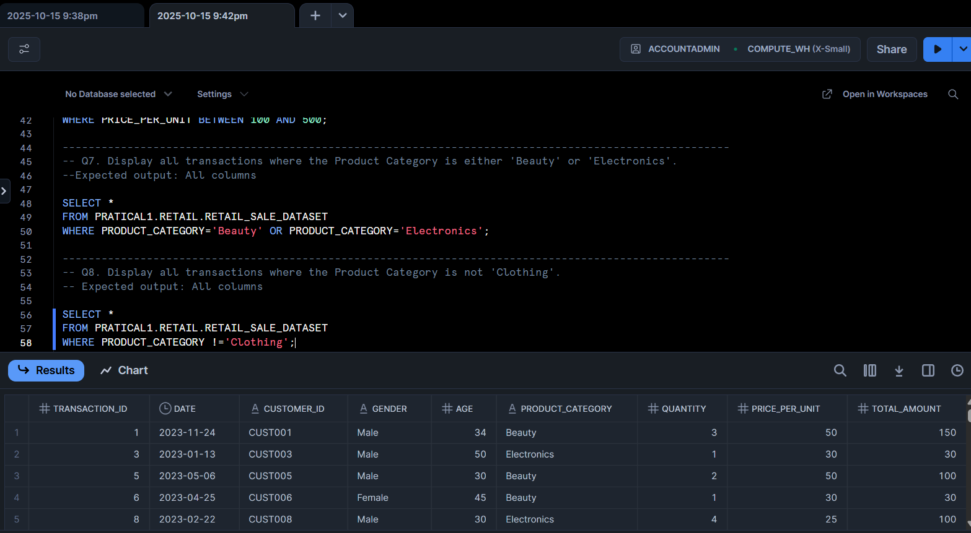

-------------------------------------------------------------------------------------------------------
-- Q9. Display all transactions where the Quantity is greater than or equal to 3.
-- Expected output: All columns
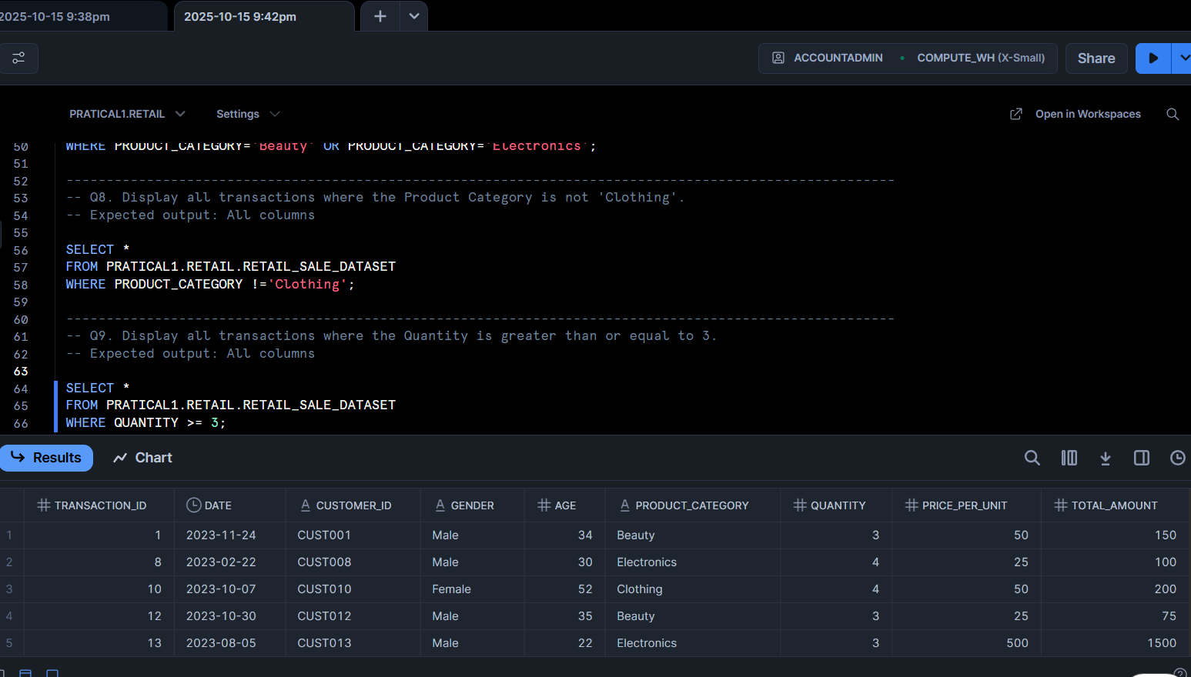
-------------------------------------------------------------------------------------------------------
-- Q10. Count the total number of transactions.
--Expected output: Total_Transactions

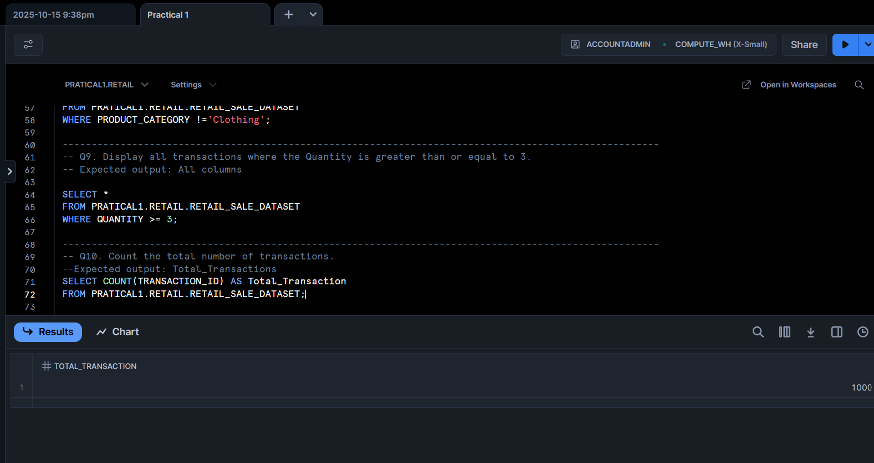

-------------------------------------------------------------------------------------------------------
-- Q11. Find the average Age of customers.
-- Expected output: Average_Age
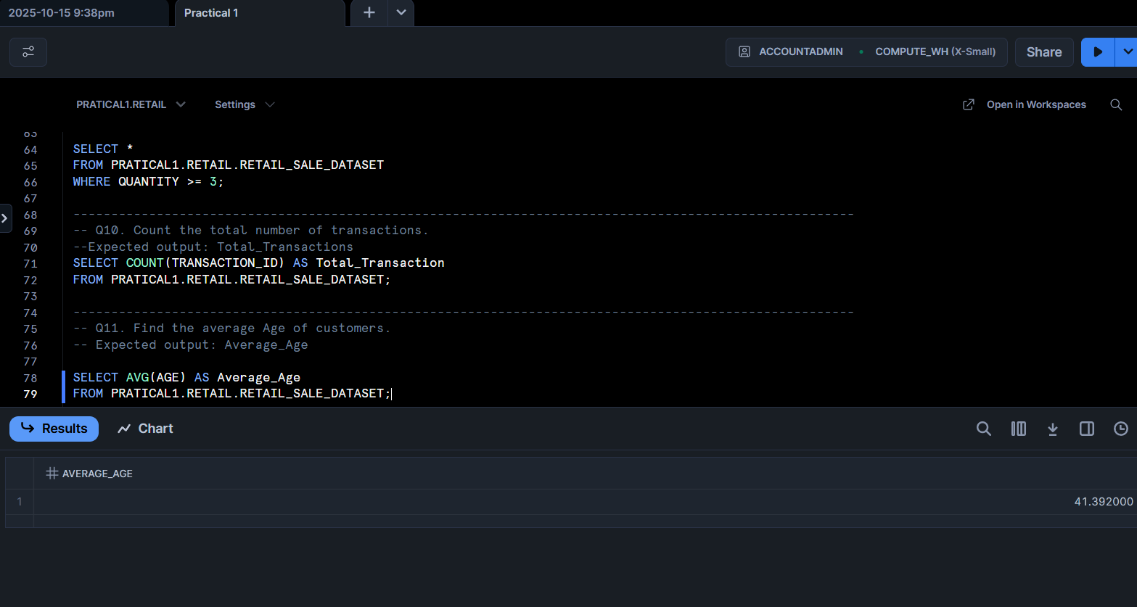
------------------------------------------------------------------------------------------------------
-- Q12. Find the total quantity of products sold.
-- Expected output: Total_Quantity

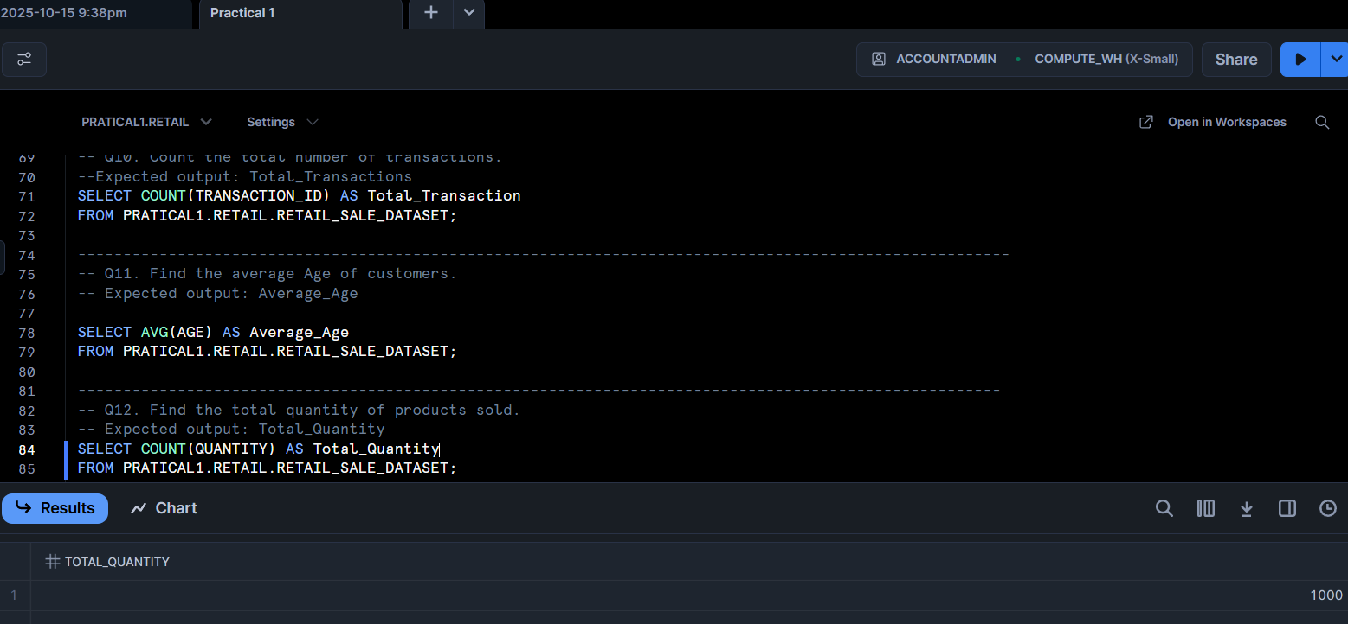

------------------------------------------------------------------------------------------------------
-- Q13. Find the maximum Total Amount spent in a single transaction.
-- Expected output: Max_Total_Amount

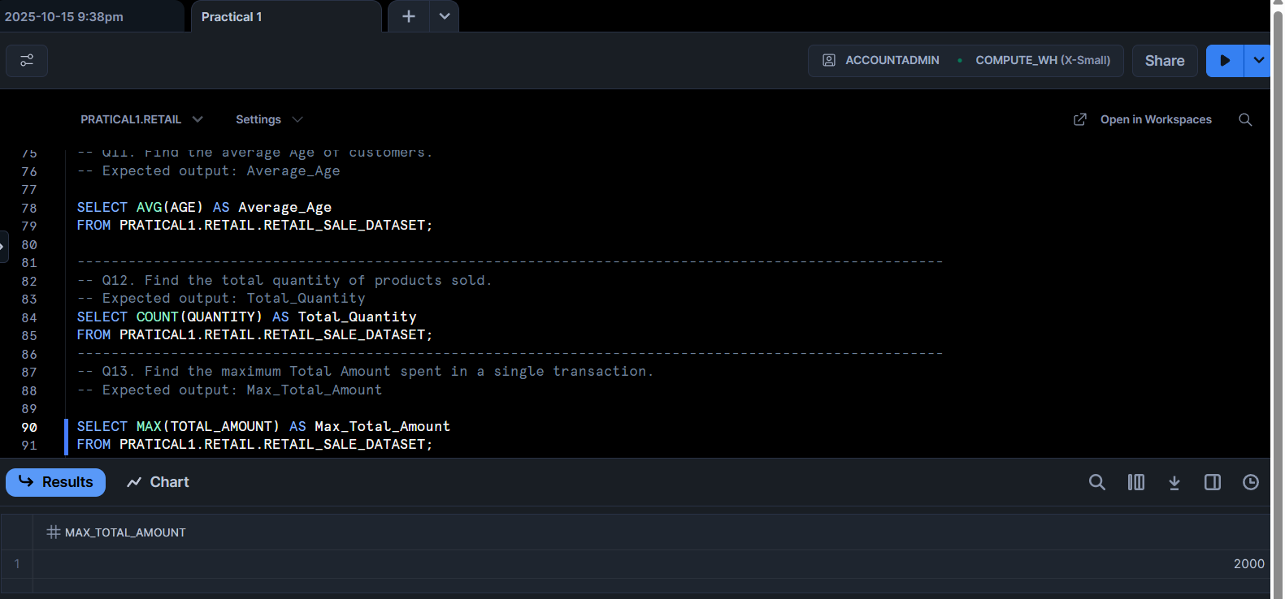
------------------------------------------------------------------------------------------------------
-- Q14. Find the minimum Price per Unit in the dataset.
-- Expected output: Min_Price_per_Unit
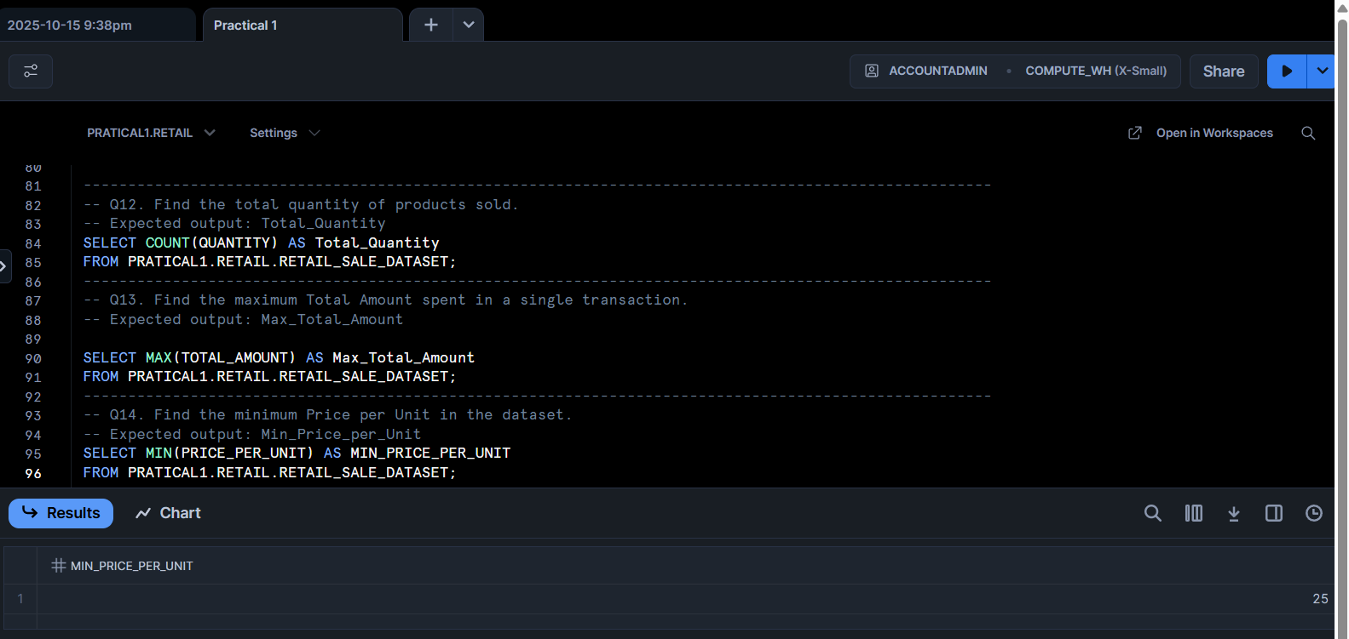

------------------------------------------------------------------------------------------------------
-- Q15. Find the number of transactions per Product Category.
-- Expected output: Product Category, Transaction_Count

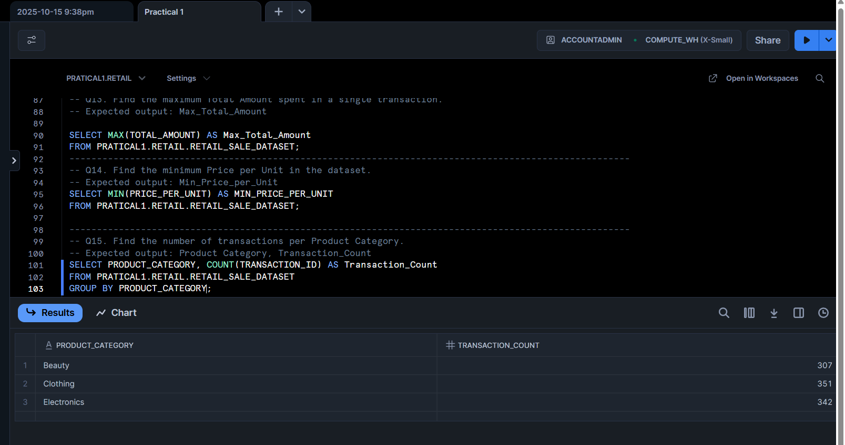

------------------------------------------------------------------------------------------------------
-- Q16. Find the total revenue (Total Amount) per gender.
-- Expected output: Gender, Total_Revenue

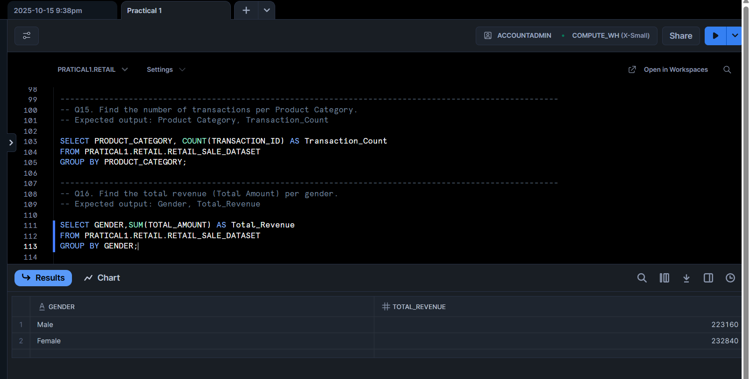
------------------------------------------------------------------------------------------------------
-- Q17. Find the average Price per Unit per product category.
-- Expected output: Product Category, Average_Price
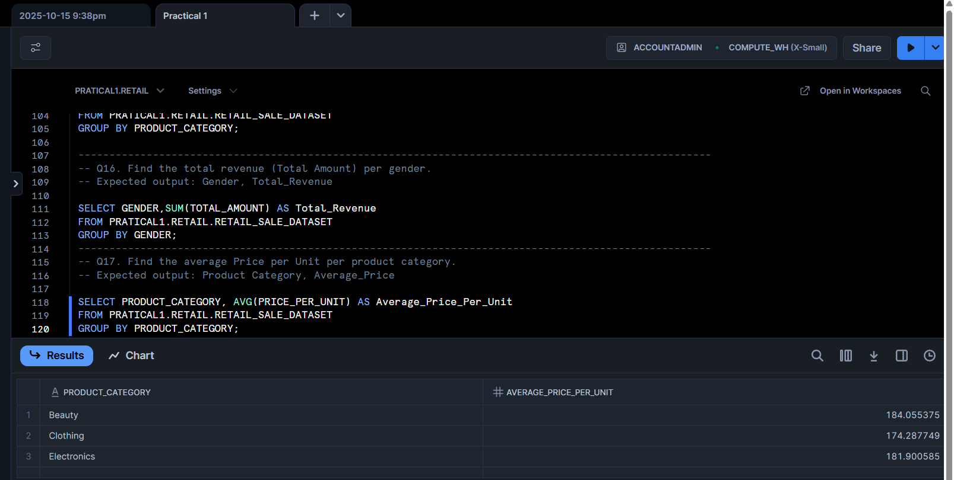

------------------------------------------------------------------------------------------------------
-- Q18. Find the total revenue per product category where total revenue is greater than 10,000.
-- Expected output: Product Category, Total_Revenue

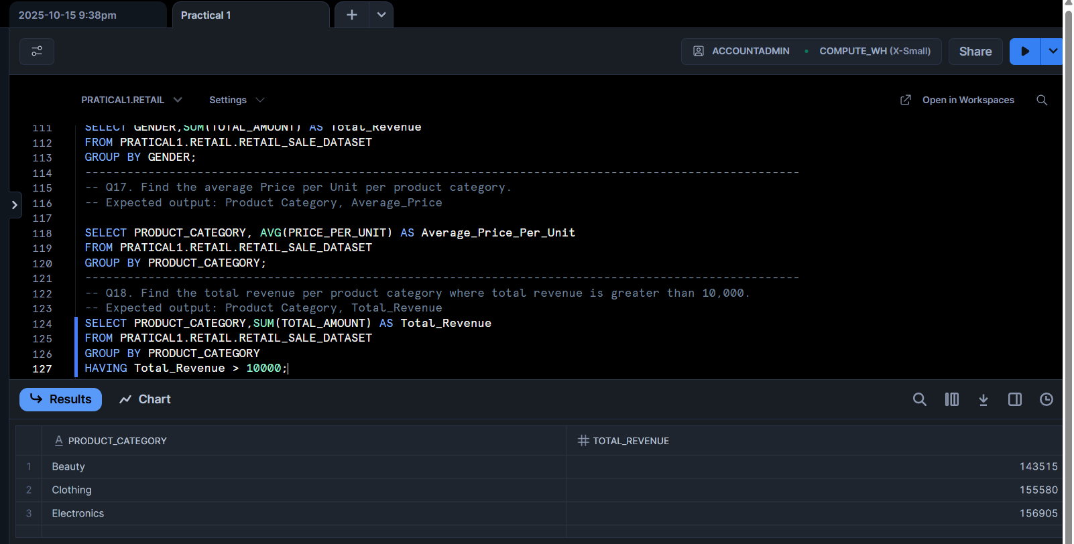

------------------------------------------------------------------------------------------------------
-- Q19. Find the average quantity per product category where the average is more than 2.
-- Expected output: Product Category, Average_Quantity
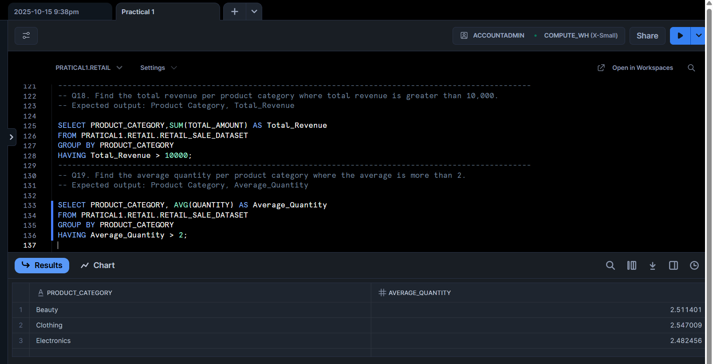

------------------------------------------------------------------------------------------------------
-- Q20. Display a column called Spending_Level that shows 'High' if Total Amount > 1000, otherwise 'Low'.
-- Expected output: Transaction ID, Total Amount, Spending_Level
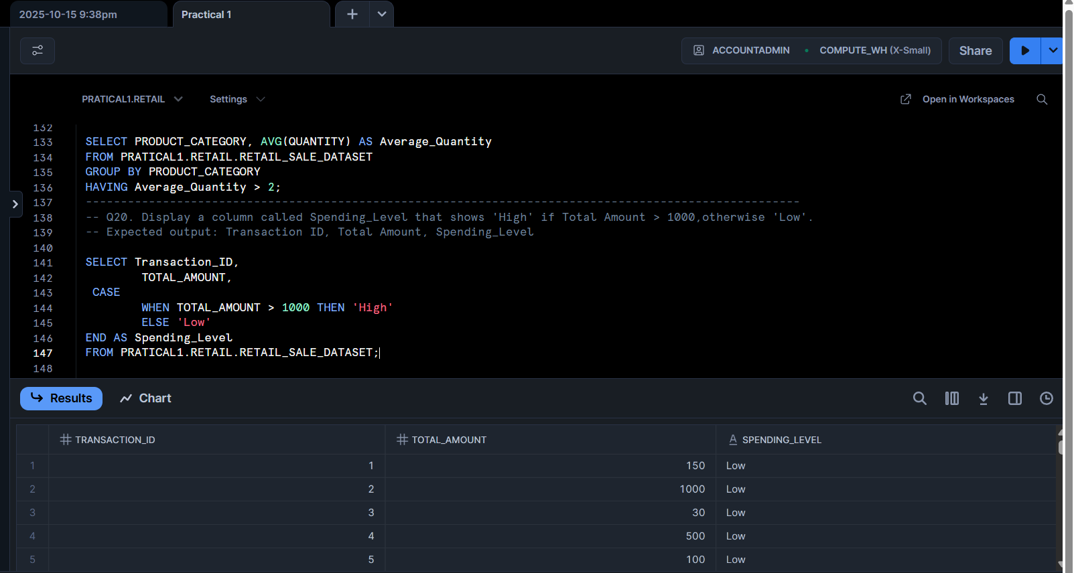

------------------------------------------------------------------------------------------------------
-- Q21. Display a new column called Age_Group that labels customers as:
-- • 'Youth' if Age < 30
-- • 'Adult' if Age is between 30 and 59
-- • 'Senior' if Age >= 60
-- Expected output: Customer ID, Age, Age_Group
